Lap Timer Control Function – S550 Specific - CGEA1.3

Functional Description

The following STSS is a spin off of the original Lap Timer Control Function CGEA 1.3 and customized for the S550 MY18 vehicle line up. The changes should be applied for 12” clusters. Feature support on other sizes are on a case basis. Lap Timer is a part of the Track Application set of features that allow customers to record time and speed for all the laps on a track of their choice
The Lap Timer feature allows the customer to select one of 3 tracks and have lap times recorded for each. The cluster calculates the average speed based on track length and measures lap times for each lap. The cluster also calculates and display split times comparing current lap time with the previous lap.

The cluster will display current lap time, average speed, the lap number and split time for the track selected by the driver. The lap number is incremented manually by the driver by pressing the buttons on the 5-way switch on the steering wheel. At the end of the “run”, the cluster will save all successful laps and sessions on the track.
At the end of the track drive, the customer will have the ability to view the results under the “View/Clear Results” tab in the Lap Timer menu. The best track times for each track and the average speed during that track drive will automatically be saved by the cluster.

Currently for recording track performance data, the maximum number of laps supported per session is 25. A maximum of 100 sessions can be stored. The oldest data is cleared off if additional session recording is requested. Users will be able to record data for 3 tracks.

The Lap Timer will not function when the vehicle is driven with a “MyKey”. The Lap Timer Control Function correlates the VehOverGnd_V_Est signal from the ABS_ESC, the OdoCount signal from the PCM and the Operational mode to process the timer function. Date and time information is referenced from Global Clock Setting feature

Interfaces

Interface Context Diagram (I/O Block Diagram)
- Lap Timer Control Function Context Diagram
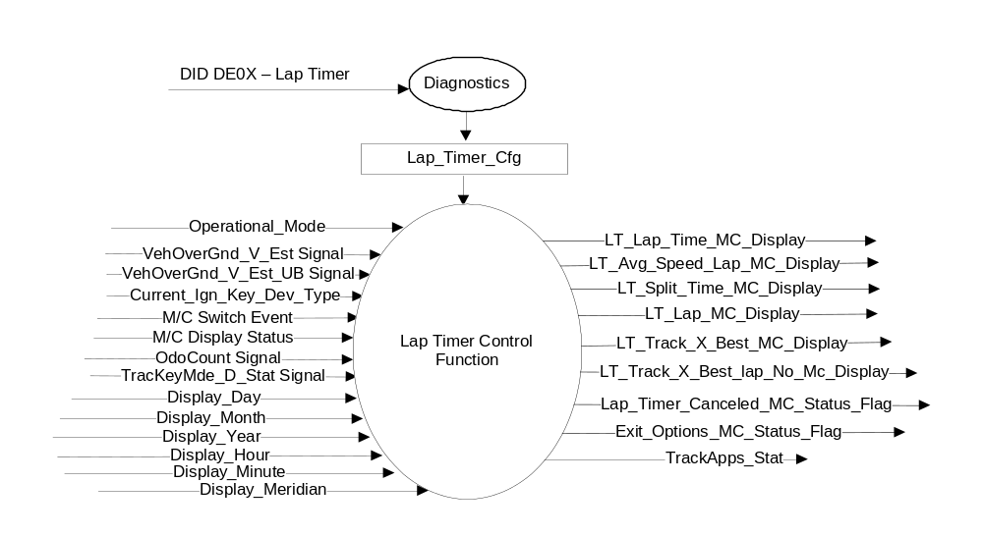

Inputs
- INTERNAL:
  - Operational_Mode: Refer to section Operational Modes
  - Current_Ign_Key_Dev_Type: Used to indicate the type of key currently in use in the vehicle. See MyKey Control Function SPSS for further definition
  - Lap_Timer_Cfg
  - OdoCount
  - M/C Switch Event
  - M/C Display Status
  - Display_Day
  - Display_Month
  - Display_Hour
  - Display_Minute
  - Display_Meridian

- MUX messages on the CAN Bus

- VehOverGnd_V_Est and VehOverGnd_V_Est_UB Signal
Signal Name | Size (bits) | Detail | Units | Res. | Offset | State Encoded | Min | Max
VehOverGnd_V_Est | 10 |  | kph | 0.01 | 0 |  | 0 (0x0) | 655.33 (0xFFFD)
 |  | Unknown |  |  |  | 0xFFFE
 |  | Fault |  |  |  | 0xFFFF
VehOverGnd_V_Est_UB | 1 |  |  | 1 | 0 |  | 0 (0x0) | 1 (0x1)
 |  | Unchanged_Data |  |  |  | 0x0
 |  | Fresh_Data |  |  |  | 0x1

- OdoCount Signal
Signal name | Size (bits) | Detail | Units | Res. | Offset | State Encoded | Min | Max
OdoCount | 8 |  | meters | 0.2 | 0 |  | 0(0x0) | 50.8 (0xFE)
 |  | Invalid |  |  |  | 0xFF

- TracKeyMde_D_Stat Signal
Signal Name | Size (bits) | Detail | Units | Res. | Offset | State Encoded | Min | Max
TracKeyMde_D_Stat | 2 |  | SED | 1 | 0 |  | 0  (0x0) | 3  (0x3)
 |  | ModeNotDetermined |  |  |  | 0x0
 |  | Active |  |  |  | 0x1
 |  | NotActive |  |  |  | 0x2
 |  | NotUsed |  |  |  | 0x3

Outputs
- LT_Lap_Time_MC_Display
- LT_Avg_Speed_MC_Display
- LT_Split_Time_MC_Display
- LT_Lap_MC_Display
- LT_Track_X_Best_MC_Display
- LT_Track_X_Best_lap_No_Mc_Display
- LT_OverallBest_MC_Display
- Lap_Timer_Canceled_MC_Status_Flag
- TrackApps_Stat

0x0 | Inactive
0x1 | TrackApps – Acceleration Timer
0x2 | TrackApps – Brake Performance
0x3 | TrackApps – Line Lock
0x4 | TrackApps – Lap Timer
0x5 | TrackApps – Start Option
0x6 | Reserved
0x7 | TrackApps – Return to QAM

Function/Performance

Operational Modes

Mode | Differentiating Vehicle Conditions
Sleep Mode | Lap Timer Function Inactive
Limited Mode | Lap Timer Function Inactive
Normal Mode | Lap Timer Function Active / Inactive
Crank Mode | Lap Timer Function Active / Inactive

Voltage Levels

Refer to Cluster Features table located in the Operational Modes and Voltage Range Strategies section in this SPSS.

Human-Machine Interface

Visual

Indicator Graphics / Display Format
Example menu structure (refer to program specific menu structure for accurate and approved graphics)

Menu Level 1 | Menu Level 2 | Menu Level 3 | Menu Level 4
Track Apps | Acceleration Timer  Brake Performance  Line Lock  Lap Timer -- [OK] | Track 1 | Press [OK] to begin  <<If lap is completed show Track X data (X = 1, 2 or 3)>>  Press [OK] to measure / Hold to Exit
Track Apps |  | Track 2
Track Apps |  | Track 3
Track Apps |  | View Clear Results

Example graphics for the 12” TFT (not all graphics are shown here):
Select Track App
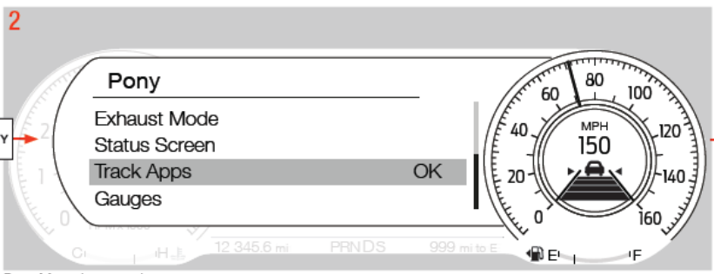
Pony_Menu_MC

User Journey:
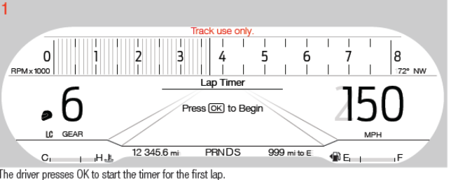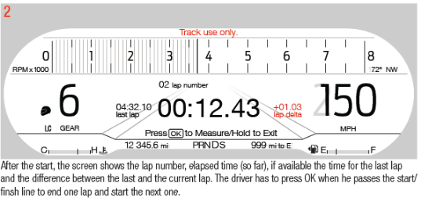
Lap_Timer_UJ_Begin_MC Lap_Timer_UJ_Running_MC

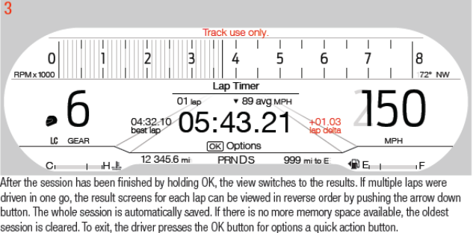
Lap_Timer_UJ_End_MC

View / Clear Results
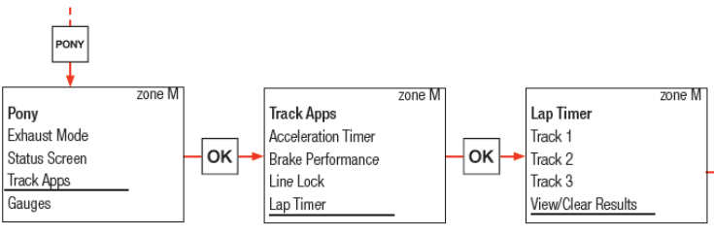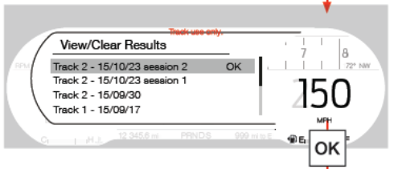
Pony_Menu_MC Track_Apps_MC Lap_Timer_MC Lap_Timer_ViewClear _MC

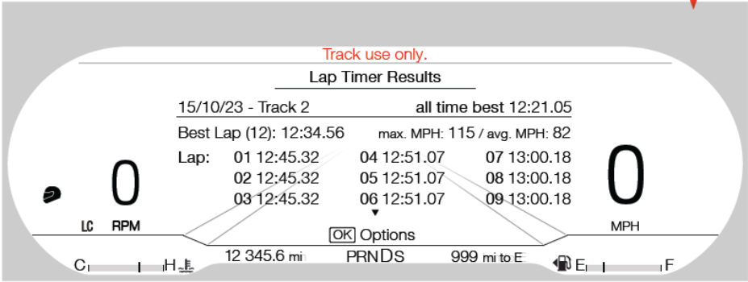
Lap_Timer_Results_MC

Clear Results:
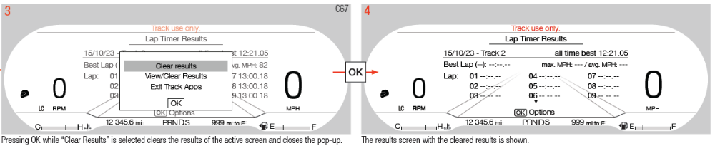
Lap_Timer_Results_Options_MC Lap_Timer_Results_MC

Indicator Color Coordinates

Indicator Characteristics

Audio

None

Switch Control Logic

Not applicable.

System Accuracy

- The real time current lap timer (LT_Lap_Time_MC_Display) shall be displayed in the format of XX:YY:Z (mins, seconds, 10th second). However, upon completion of the lap, the time shall be displayed and saved in the format of XX:YY:ZZ (mins, seconds, 100th second).
- The lap number (LT_Lap_MC_Display) shall be displayed as a XY number (suppress leading zero).There is a max limit of 25 laps for each track selected.
- The average speed of every lap (LT_Avg_Speed_MC_Display) shall be displayed in the format of XXY.Y mph or kph (suppress leading zeros).
- The Lap Timer split time (LT_Split_Time_MC_Display) shall be calculated and displayed in the format of +/- XX:YY.ZZ (mins, seconds, 100th second).

Operation: Performance and Functional

Subsystem Algorithm Flowchart / State Diagram

- Lap Timer Display Configuration

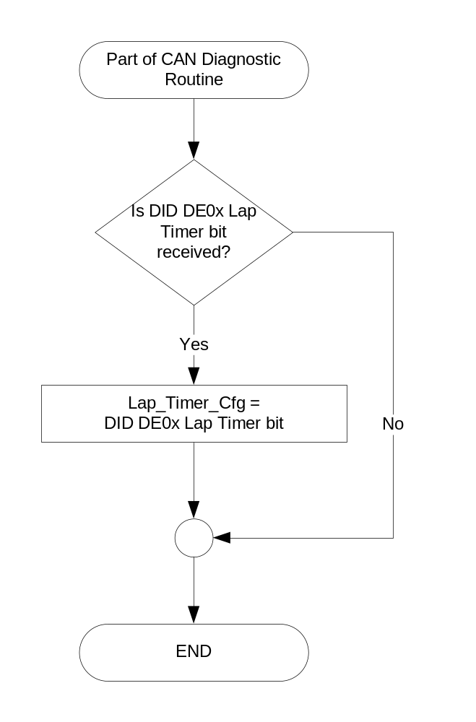

Lap Timer Menu Items Selection Function
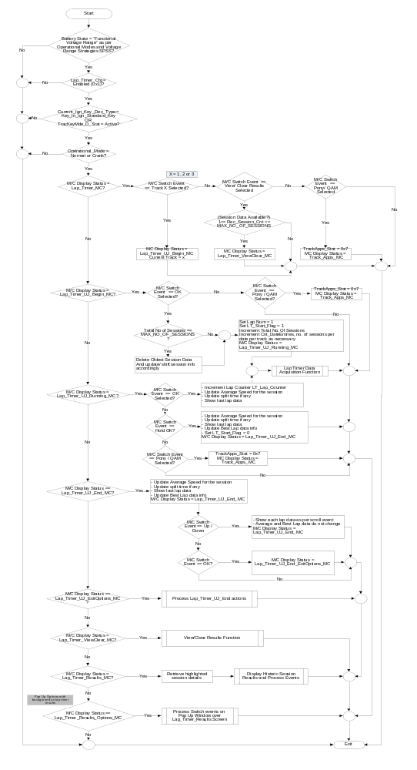

- Lap Timer Data Acquisition
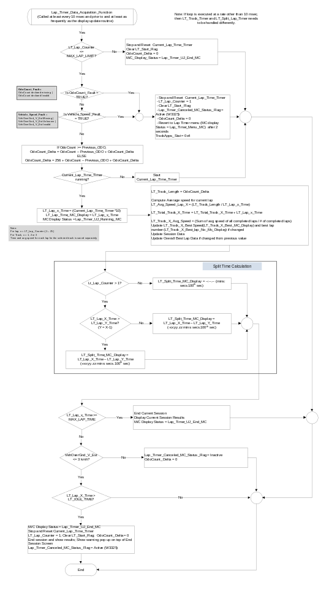
- View/Clear Results Display Function 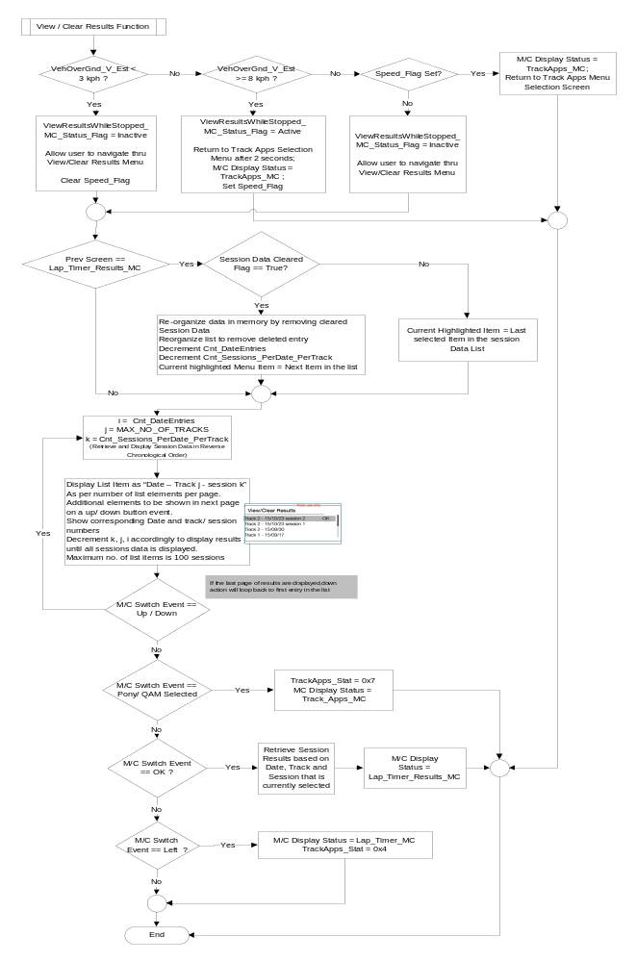
- Display Historic Session Results and Process events 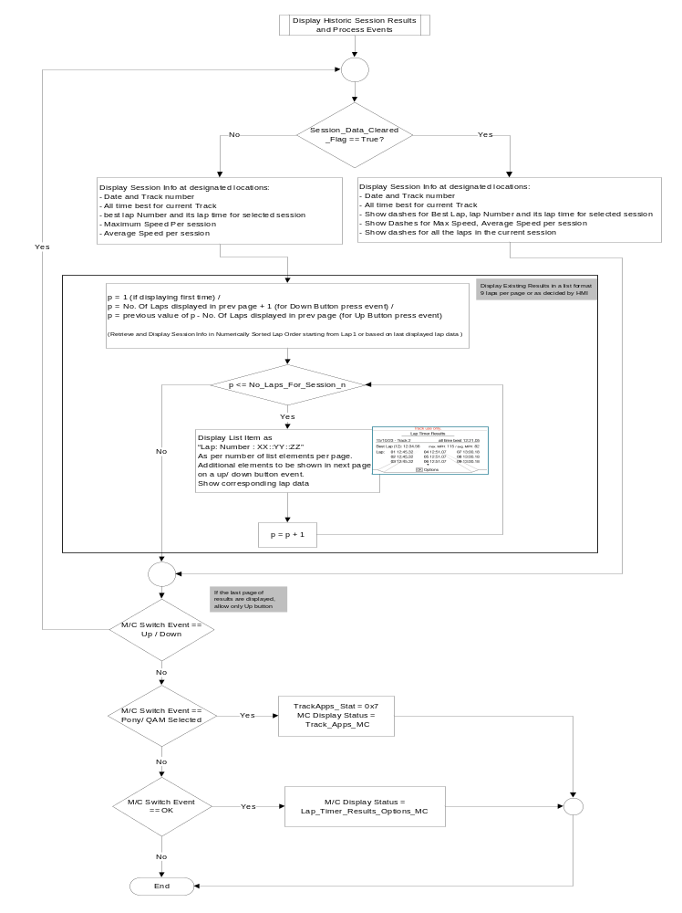

- Process Events on Pop Up Window over Lap_Timer_Results Screen
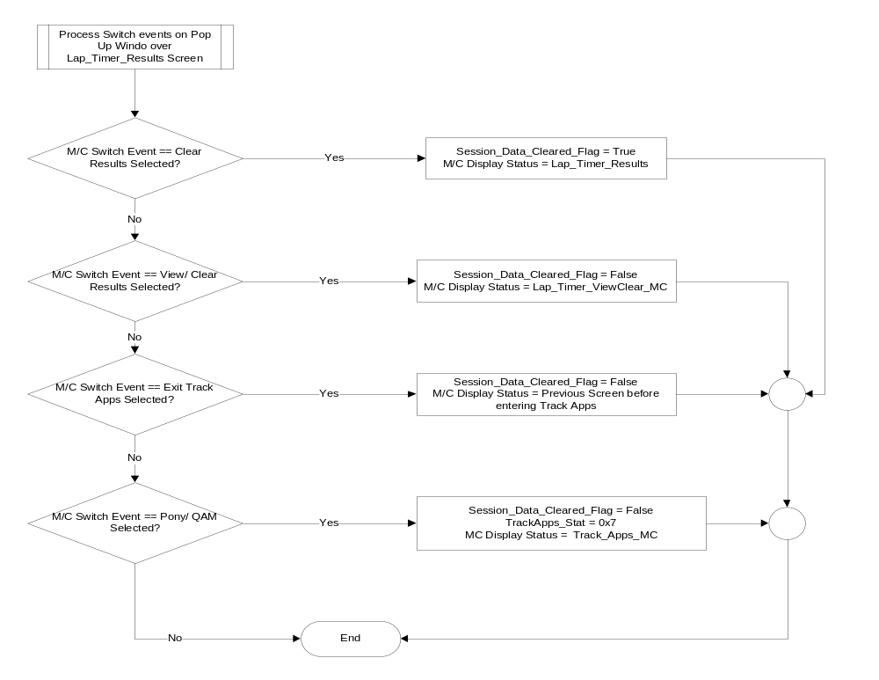

- Process User Journey End - Results – Options Screen

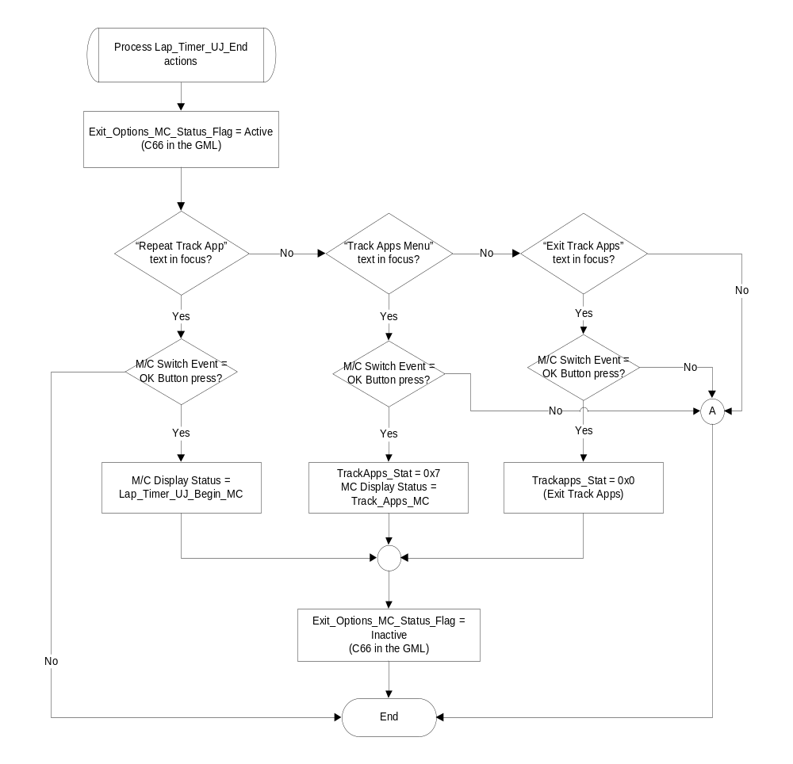

Operation Description (supports algorithm flowchart /state diagram)

- View/Clear Results while Stopped Status Flag to Display Mapping

Lap_Timer_Canceled_  MC_Status_Flag | ViewResultsWhileStopped_  MC_Status_Flag | MC Message ID
Inactive | Active | W3263
Active | Inactive | W3325

General Functionality:

- All the screens under the Lap Timer menu shall display “Track Use Only” on the screen at all times.
- The cluster shall use the odometer function to calculate distance traveled.
- The lap timer feature is only operational with engine running.
- If at any given time during the process, if any of the input signals is declared missing, invalid or unknown, the lap timer shall be stopped and the track drive shall be canceled and the cluster should revert back to the Lap Timer menu. The cluster shall save results for all completed laps, discard data for incomplete laps, activate W3325. The current lap timer and lap number shall be reset to their initial value as well.
- The cluster shall save data for each lap for a given track automatically after completion for every lap.
- The cluster shall save the total track time and average speed for that particular track after completion of a given track drive. This data shall be saved throughout key cycles so that it can be compared with future or past performance on the same track to calculate and display “All Time Best” results.
- Once a better track time has been calculated for a given track, the cluster shall automatically replace the data under “All Time Best” results (if applicable) for the given track.
- The Lap Timer feature shall not be available if Lap_Timer_Cfg is set to disabled (0x0) or if the vehicle is driven using MyKey

Track Apps “View” Related functionality:

- The supported drive modes for S550 are Normal, Sport, Track, drag and snow/wet mode.
- Track “view” is shown when user selects Track or Drag drive modes explicitly. If the user is in other drive modes, opening a Track App (except for the Performance Shift Inidcator) will force the cluster into Track View. Navigation and ADAS will disappear while a Track App is being used.
- If current app is Lap timer, user can view / clear the results of the current lap and previous laps after the lap is done
- After the Track App action is completed, a pop-up can be opened for more options. User has the convenience of
  - Repeating the current Track App
  - Navigate to the Track Apps Menu to proceed to other Track Applications
  - Exit Track Apps completely
If the user navigates to other track apps, the current view shall continue to be in “Track View” and the menu list will be shown with the list of Track Apps for the vehicle.
Pressing back button in this menu will bring the view as per the current drive mode. For example, if user is in Snow Mode prior to entering a track apps, the view switches to Normal from Track view once the app is exited. Similarly, if the user exits track apps completely, the view switches based on the current drive mode.
- The final screen of Track Apps advises the user to hold the OK button to exit the Track App.
If the user wants to abort a Track app, it can be done by pressing the Pony Quick Action Button. The corresponding Pony menu will open up and the view switches back to the actual state according to current drive mode or the view that is set in the Cluster
- Track App – deactivated or cancelled or Not available
  - If the track app or laptimer is deactivated by the vehicle due to its current condition, a pop-up is shown
  - Pop – Up Example image shown in Section 1.3.3. Refer actual HMI Wallpapers
  - After the pop-up disappears, the Track Apps Menu (or the Quick Action Menu) is shown in the IOD Area which shows the track apps list. If the user selects one of the Available Track Apps, the Track View is shown or retained, else the view switches back to the one corresponding to drive mode

Track Apps – Lap Timer – User Journey:
- The user can select only one of the available tracks to measure lap times at any given time.
- Once the lap timer has been started by the user, the lap distance is calculated by the cluster every time the user presses the “OK” button to advance to the next lap
- Once the user presses and holds the “OK” button for 2 or more seconds, the lap timer stops even if the user is in the middle of a lap. Data shall be calculated for all completed laps only. Data shall not be calculated for any incomplete laps
- The cluster shall display lap time on a real time basis. The “real time” lap timer shall be displayed accurately to 10th of a second. However, the final time for each completed lap shall be displayed and saved to an accuracy of a 100th of second
- Split time and average speed are calculated at the completion of each lap. Split time shall be displayed and saved to an accuracy of 100th of a second
- Once the user presses the “OK” button to start a new lap, the average speed and split time shall be shown as dashes since calculation of those variables cannot be calculated until end of the lap. Split time shall also be displayed as dashes for the first lap
- After selecting one of the tracks (1,2, or 3) in the Menu Level 3, the “Lap Timer” Screen will show up with an OK button to start the timer of the first lap for the Track in current session
- Example image is shown in section 1.3.3 for user Journey. The screen should show the current lap number, the elapsed time. If the time for last lap is available, then it would be shown along with the difference between the last lap and current lap
- End of lap is marked when the user presses OK. The next lap is automatically started
- End of Session is marked when the user presses and holds the OK button. The view automatically switches to the results. If multiple laps are done in one go, the result screens for each lap can be viewed in reverse order by pushing the arrow down button. The Up button will decrement the lap # and the Down button shall increment the lap #
- The session is automatically saved. The recent 100 session info is saved. Oldest session is cleared
- After the results are viewed, user needs to press OK for more options. Then the Quick Action Menu opens up to help user to repeat the track app or track apps menu. The user can then navigate to view all results or go back to the Lap timer screen to repeat another session or exit the track apps.
- The Date information needed to update and store the lap info needs to be taken from Global Clock Setting Control Function – CGEA 1.3
- If there is any fault scenario due to signal missing or invalid, do not save the lap data. Even if we have a new Overall Best Lap Data, since the session data is not saved, the overall best lap data will not be updated

Track Apps – View / Clear Results:

- User shall be able to navigate to the View /Clear Results menu option which shows the results, datewise sorted with the most recent one on the top
- If the user exits this screen by pressing back, re-navigating to this menu screen will bring the cursor to the top of the list
- The suggested format for display would be <<Date – Track No – Session No - [OK]>>
- User shall be able to use the down and up arrow navigation buttons to scroll to the required date and session info and the corresponding results
- The data is maintained for 100 list entries. If additional recordings occur, delete oldest
- After scrolling to the desired session entry, if the user presses OK to look into detailed results, user is taken to the “Lap Timer Results” Screen. All info related to the session like the best lap time, “all time best” lap time, maximum speed in vehicle units and average speed for the session are displayed. User can scroll down to see the info per lap to a maximum of 25 laps. If the user presses “back” to come back to View Clear Results screen, last selected session item is to be highlighted if the session data has not been cleared
- Long press for scrolling will trigger fast scrolling method which is applicable to all HMI menus per cluster type
- Pressing OK on this (Lap Timer Results) screen provides user with the option of “Clear Results” or “navigate to View / Clear Results screen” or to “Exit Track Apps”
- Pressing OK on Clear Results will close the pop-up after clearing the results of the active screen. Example wallpapers are provided in section 1.3.3. The corresponding list entry is also deleted in the session list on “View Clear Results” screen
- Pressing OK on “View/Clear Results” will navigate to the previous screen and the cursor position will be on the entry after the deleted one
- Pressing OK on “Exit Track Apps” will exit the tracks apps and bring the view to the one corresponding to the current drive mode

Function Safety Classification (EMC)

Class B

Memory Storage

Parameter Name | Description | Value at Battery Connect | Value at Module Wake-up
VehOverGnd_V_Est Signal | Vehicle speed input from ABS_ESC. | 0 kph (0x0) | 0 kph (0x0)
VehOverGnd_V_Est_UB Signal | Vehicle speed update bit | 0 (0x0) | 0 (0x0)
Odocount Signal | Odo count input signal from PCM | 0x0 | Do not init
TracKeyMde_D_Stat signal | Input from BCM providing status of TracKey | ModeNotDetermined (0x0) | ModeNotDetermined  (0x0)
LT_Lap_Time_MC_Display | Output Time measured for each lap on a given track. | 00:00:00 secs | 00:00:00 secs
LT_Avg_Speed_MC_Display | Output Average vehicle speed calculated for each lap on a given track. | 0.0 mph/kmh | 0.0 mph/kmh
LT_Split_Time_MC_Display | Out split time calculated between current lap and the previous lep. | 0.0 secs | 0.0 secs
LT_Lap_MC_Display | Output lap number displayed | 1 | 1
LT_Track_X_Best_MC_Display | Output best track information display | 0x0 | Use Stored Value
LT_Track_X_Best_lap_No_Mc_Display | Output best track information display | 0x0 | Use Stored Value
LT_OverallBest_MC_Display | Output overall best track information display | Use Stored Value | Use Stored Value
Lap_Timer_Canceled_MC_  Status_Flag | Output warning flag | Inactive | Inactive
Lap_Timer_Cfg | State indicator for feature presence controlled via CAN at EOL at VO plant. Set to Disabled at Cluster Supplier Manufacturing Plant | Use Stored Value | Use Stored Value
ViewResultsWhileStopped_MC_Status_Flag | Output warning flag activated when trying to access results while driving. | Inactive | Inactive
Display_Hour | Internal variable indicating the value to display for the Hour. | 0x0 | 0x0
Display_Meridiem | Internal variable indicating the value to display for the Meridiem. 0x0 = AM; 0x1 = PM. | 0x0 (AM) | 0x0 (AM)
Display_Minute | Internal variable indicating the value to display for the Minute. | 0x0 | 0x0
Display_Month | Internal variable indicating the value to display for the Month. | 0x1 | 0x1
Display_Year | Internal variable indicating the value to display for the Year. | 0x0 | 0x0
TrackApps_Stat | Internal Variable to indicate the current message center display screen | 0x0 | 0x0

Parameter Name | Description | Unit | Res. | Range/Value
LT_Lap_Counter | Counter to keep track of laps completed on a given track | # | 1 | 1 to MAX_LAP_LIMIT
MAX_LAP_LIMIT | Maximum number of laps allowed on a given track | # | 1 | 25
MAX_LAP_TIME | Maximum time allowed for each lap, after which lap timer will be aborted. | sec | .01 | 599.99 seconds  (09:59.99 mins)
LT_IDLE_TIME | Time after which lap timer function will be aborted if vehicle speed remains <= 3 kph. | Mins | 1 | 2 minutes

Prove Out

No

Error Handling

Missing Message Strategy

The signals will be declared missing as per the Diagnostics section of this SPSS.

DTCs states and history will be determined as per the Diagnostics section of this SPSS.

If Lap_Timer_Cfg = Disabled, the cluster shall never log a missing message DTC due to this feature.

Invalid Message Strategy

The signals will be declared invalid as per the Diagnostics section of this SPSS.

DTCs states and history will be determined as per the Diagnostics section of this SPSS.

If Lap_Timer_Cfg = Disabled, the cluster shall never log an invalid data DTC due to this feature.

Unknown Message Strategy

The signals will be declared unknown as per the Diagnostics section of this SPSS.

DTCs states and history will be determined as per the Diagnostics section of this SPSS.

If Lap_Timer_Cfg = Disabled, the cluster shall never log an unknown data DTC due to this feature.

Diagnostics

Self Test
None

Engineering Test Mode
Reference section “Dealer / Engineering Test Mode (ETM)”

Part II Performance
Reference Part II Diagnostic Specification

Supported Diagnostic Trouble Codes (DTCs)

DTC | Description
C12100 | Lost Communication with ABS_ESC
C41581 | Unknown Data Received from ABS_ESC
C41500 | Invalid Data Received from ABS_ESC

DID DE0X
Block  Num | Block Description | Size (bits) | Byte | Bit | State: Description | "0" | "1" | Default | Comments
PACKETED BLOCKS
$0X | Option Content (B&A) | 1 | * | * | Lap Timer | Disabled | Enabled | Disabled
*Byte and bit location to be identified in Part II Specification for this cluster

Reference Specification

- Func. Criticality EC-0048
- Mod. PWR-up / Reset EC-0049
- Low-High Vol. Perform. EC-0058
- Jump Start EC-0062
- Instr. & Gauges (indic. Grad) IS-0015
- Oper. Voltage Perf. IS-0052
- Oper. Voltage Func. IS-0053
- Symbol Usage 01-0238 / 01-0239
- Symbol Leg. 01-0240
- Placement - Parts Loc. 03-0001
- Glare/Reflections 16-0068
- Reflection 17-0018
- Harmony: Graphics / Font / Ill. 17-0040
- Ergo - Access. 17-0052
- Ergo - Operablility 17-0053
- Control & Display Loc. 17-0060
- Logical grouping Function and Usage 17-0062
- Assoc. of Controls with Disp. & elem. 17-0063
- Ill. Controls & Disp. 17-0074
- Id. Legibility 17-0081
- ID. Coding / Labeling 17-0083
- Logic of Op. 17-0120
- Op. Stereotypes 17-0121
- Interpretation 17-0122
- Feedback 17-0124

Revision History

STSS Module Revision History

Revision Level | Name | Change Description | Date
1.0 | R. Chalanti | Initial release for CGEA1.3 S550 MY2018 MCA as per | 03/28/2016

